“A Charlie Brown Thanksgiving” (25 min) – TEACHER Sheet
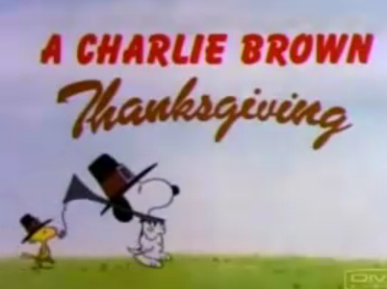
Using the cartoon:
Answers:
What does “thanksgiving” mean? Traditional Holiday in the USA and Canada when they give thanks for the “harvest”, the food. Normally they have this special dinner with turkey, pumpkin pie and cranberry sauce and in the end of the day they say what they are thankful for.
Today, Thanksgiving is celebrated on the second Monday of October in Canada and on the fourth Thursday of November in the United States.
What is the season of the year? Fall, Autumn
Is it between which two other holidays? It is between Halloween and Chistmas
How is Peanuts’s mood (his temper/humor)? He’s always in a bad mood, he’s a pessimist.
What does Peppermint Patty decide to do? She invites herself and some friends (Marcie and Franklin) to go to Charlie’s house for Thanksgiving dinner. She doesn’t let him speak through the phone.
What do they have for dinner? Pieces of Toast with butter,Popcorn, Pretzel sticks and candies/sweets.
What is Marcie thankful for ? ”We should be thankful for being together.”
What do Snoopy and Woodstock have for dinner in the end ? Turkey with vegetables for Main course and Pumpkin pie for Dessert.

Superlatives:
The most stupid person alive. / One of the greatest traditions ... /
The biggest / The most important tradition . . . / The cutest thing.
The biggest bash.

Comparatives:
I better talk to her. / ... greater news.... / ... serve dinner earlier ...

Glossary on the Student Sheet:

Honor (AE) / Honour (BE) =
commotion = an agitated disturbance
bash of the year = the party of the year
Pretty good = Quite / Very good
Prayer/ say Grace = to pray to God
Gee = Wow, Oh my
Misunderstandings = disagreement / failure to understand

“Thanksgiving Vocabulary” (Pre-Teach with the flashcards):
Turkey / Cranberry Sauce / Pumpkin Pie / Pilgrims x Indians / Mashed Potatoes / Invite / Honored Guests / Feast (celebration with abundant food)

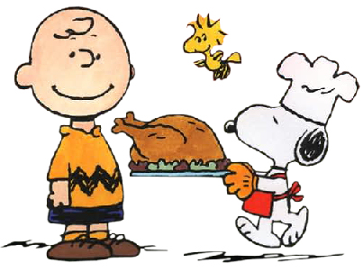
“A Charlie Brown Thanksgiving”

What does “thanksgiving” mean?
What is the season of the year?
Is it between which two other holidays?
How is Peanuts’s mood (his temper/humor)?
What does Peppermint Patty decide to do?
What do they have for dinner?
What is Marcie thankful for ?
What do Snoopy and Woodstock have for dinner in the end?

Write Comparatives (3) and Superlatives (5) from the cartoon:

GLOSSARY
In order they appear:

What’s that got to do with anything ? (have got to do)
What is the relation between these...?

You’ll put it away and I’ll land flat on my back and kill myself
I’ll fall down
turn down = reject or refuse
fade away = disappear/ dissolve
already ? = now ? / so soon ?
essay = a writing task
keep track = follow / keep informed
upon us = on us (the holiday is getting closer / approaching)
cute - cutest = attractive, charming little boy
sly devil / dog = naughty boy (littlle devil / bad boy)
folks = “parents”
wishy-washy = silly / idiot boy
blockhead = idiot
“You were kind of Rough” / Brusque = rude, without manners
hurt his fellings = make somebody really sad
patch things up = conciliate
apologies = asking pardon / sorry

“Thanksgiving Vocabulary”:
Turkey / Cranberry Sauce / Pumpkin Pie / Pilgrims x Indians /
Mashed Potatoes / Invite / Honored Guests /
Feast (celebration with abundant food)

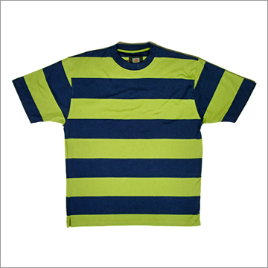
stripped shirt

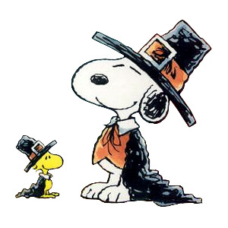 the clothes you wear in particular occasions
outfit
(Snoopy wears the Pilgrims outfit - costume)
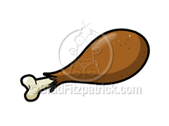
drumstick

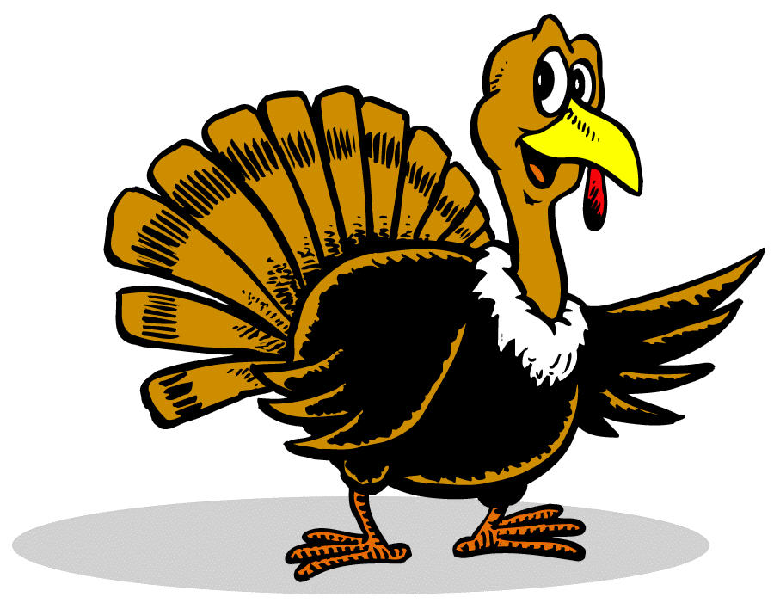
neck

“Just save me a drumstick and the neck”

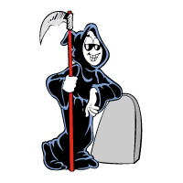
I’m doomed =

I’m condemned to death.
“I’m going to die.”

